AP WORLD HISTORY
SUMMER ASSIGNMENT 2017

Welcome to Advanced Placement World History at Discovery!
Dr. Jayme Holaway Hicks jayme_hicks@gwinnett.k12.ga.us

Remind: Before you go any further! Please enroll in our course Remind service. We’ll use this all the time, and it is a great way for you to communicate with me directly. Even during the summer if needed! See the instructions in a separate file.

About the APWH course:
AP World History develops an understanding of the evolution of global processes and contacts, including interactions over time. This non-traditional approach looks at the common threads of humanity—trade, religion, politics, society, & technology—and investigates how each have changed and continued over time. The course traces the human experience from the emergence of Neolithic cultures to the 21st Century, C.E., emphasizing the habits of mind, writing skills, and content knowledge characteristic of a college-level world history course. Students will devote considerable time to the critical evaluation of primary & secondary sources, writing, and participation in classroom discussions/Socratic seminars.

The Summer Reading Book:
This year’s summer reading assignment is A History of the World in 6 Glasses by Tom Standage. In this book, Standage tells a popular history of the world and some of the most significant civilizations in history by following the development of 6 influential beverages: beer, wine, spirits, coffee, tea, & Coca Cola*. Each of these beverages has played a significant role in driving trade and interaction between some of the most significant regions and empires in world history. Our purpose in reading the book is to gain a sense of how civilizations and cultures develop and how they are affected by various forces (political, economic, religious, social, technological, etc.).

*(DISCLAIMER: The use of this book as a summer reading assignment in NO way represents any endorsement by the teachers of Discovery of the consumption or misuse of these beverages! The book is simply meant to provide an interesting view of civilizations and trade, from which we can initiate our year-long discussion of world history.)
Your Assignment—(1 Summative/Test Grade):
For your assignment, you will read the ENTIRE book A History of the World in Six Glasses. Don’t panic—it is very readable, and hopefully you will find it quite interesting. There are six parts to the assignment (see below). Please read the instructions carefully. You will need to bring the book and the completed assignment with you Friday, August 11, 2017**.

**Assignments completed and turned in on August 11th will receive 10 extra points. All others may be turned in for full credit anytime on nor before Friday, September 1, 2017.

How to complete your assignment: You may be asking right now, “Awww maaaan, why do we have to do this?” And, that would be a valid question. So, here goes the answer: The course is writing intensive and specific. There are three (3) types of writing requirements in this course. First, the Short Answer Question, SAQ for short. Second, the Long Essay Question or LEQ for short. And, finally the most lauded Document Based Question or DBQ. You don’t know how to do these yet, and that’s OK. This reading and writing assignment will give you a chance to work on the skills necessary to be successful in the AP World History (and any other college-level) course.
Requirements:

- Complete one (1) writing prompt for each section (Beer, Wine, Spirits, Coffee, Tea, and Coca-Cola) for a total of six (6).
- But, wait! There’s more! Choose wisely. You must have two SAQ, two, LEQ, and two DBQ responses. You know, so you don’t do all six SAQs. This makes you give each type of writing a good shot.

Grading: This assignment will be your first major grade. 90% of the grade will be based on your thoughtful completion of the assignment, 10% will be based on your attention to instructions. All portions of the assignment need to be written in blue or black ink and compiled neatly into a folder or stapled together.

Extension: During the course of our year together, you will often get opportunities to extend your knowledge and dig even deeper into some awesome crazy content. This is one of those times—for an additional 10 points! “What’s that you say, Dr. Hicks?” Yes, 10 more points. “So, what if I turn my assignment in on August 11th and do the extension?” That’s right—20 extra points. For a summative grade, this is significant! Here’s what you need to do:
- Choose three different beverages.
- Research the types of art and/or architecture being created during the same time periods.
- Choose one from each (painting, sculpture, buildings, dwellings, pottery, etc.).
- You may print the image from the internet, or for those artistically inclined, you may draw it yourself.
- For each item, include the following information:
  - Its name
  - Who created it? Note, for earlier works there may not be an artist’s exact name. We have no idea who designed the Great Ziggurat of Ur, for example. Then, use the culture that created.
  - Date
  - What is it? For example, the Titian, Venus of Urbino is an oil on canvas.
  - Articulate in a substantial paragraph the historical context under which each piece was created. For help on writing historical context, check out the example in the DBQ.
- Check out his link for some great ideas and info: Khan Academy AP Art History Required 250.
- Feel free to contact me via email or Remind with questions. jayme_hicks@gwinnett.12.ga.us
- Example:

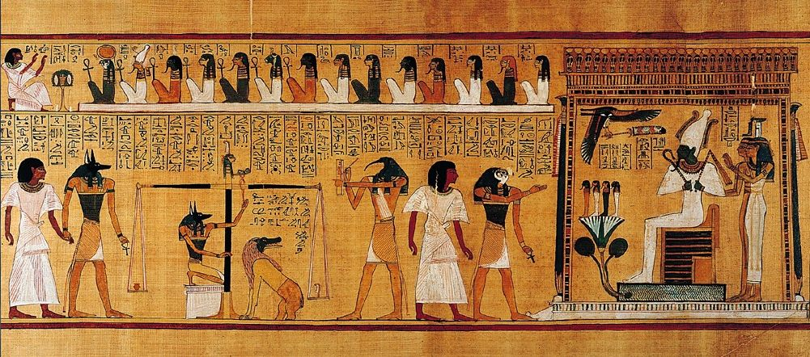

Hunefer’s Judgment in the presence of Osiris, 19th Dynasty, New Kingdom, c. 1275 BCE***, papyrus, Thebes, Egypt.

This piece was found in the tomb of a man named Hunefer, a scribe from ancient Egypt. The image portrays the idea of a ‘judgment’ in order to successfully enter the afterlife. These types of stories are common throughout recorded history across all sorts of cultures. The image above shows Hunefer being presented to Osiris, the gatekeeper to the afterlife. Ancient Egyptians left scores of items behind in tombs for historians. Much of what has been discovered reveals this culture’s keen interest in what happens to a body and soul after death. The scroll is meant to be “read” from right to left as would a cartoon with frames. Note the scale in the center. On the top you see a god named Ma’at—the god of divine order represented by the feather on top of her head. Undneath is the god Anubs; he is adjusting the scale to make sure it level. On one side of the scale you see Hunefer’s heart, and on the other side sits a feather. The feather weighs more than the heart which means Hunefer has led an ethical and honorable life; therefore, he is admitted into the afterlife to Osiris instead of being eaten by that fanged beast sitting under the scale. The Book of the Dead shows human’s early interest in and attempts to explain and prepare for life and death.

Writing prompts and instructions are on the next page followed by examples for each SAQ, LEQ, and DBQ.

Drink | Framework: SAQ  Directions: Answer each part of the question (a, b, and c) with clear answers supported by evidence. Each answer should be between 3-4 sentences for a total of 9-12 sentences per question. See example provided for clarification. | Framework: LEQ  Directions: For each question you will be provided a thesis statement. You will need to articulate in complete sentences evidence from the text that supports the given thesis. You must include two (2) specific items of evidence from the text. See example provided for clarification. | Framework: DBQ  Directions: You will be provided a question. For the question you need to write a clear thesis statement which answers the whole question. Then write a paragraph explaining the historical context in which the question was framed. This should be 4-5 sentences and explain larger themes occurring during this period that relate to your thesis. See example provided for clarification.
Beer | 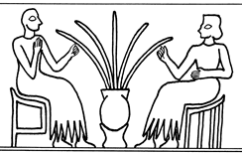  A) Identify and explain one way in which beer encouraged the transition from nomadic hunting and gathering to settled agriculture.  B) Explain how the image above could be used to support Standage’s argument that beer in the ancient era was seen as a communal beverage.  C) Identify and explain one way in which beer drew distinctions between members of ancient societies. | Analyze changes Neolithic people made to their lifestyle or technology in order to produce and secure their supplies of beer in the period from 4,000 to 1,000 BCE  Thesis: From 4,000 to 1,000 BCE the Neolithic people began following a sedentary lifestyle in order to facilitate producing and storing beer. In addition, they created writing systems to log rationings and formed pottery to better store those beer supplies over the long term. | Analyze factors which encouraged ancient peoples to use beer as a currency from 3,000 to 1,000 BCE.
Wine | A) Identify and explain one reason why wine was more of a luxury item than beer.  B) Identify and explain one way in which wine was used to differentiate between different social classes.  C) Identify and explain one way in which wine led to divisions between ethnic or religious groups. | Compare and contrast the impact of wine on social life in Greek and Roman society from 800 BCE to 400 CE  Thesis: Both the Greeks and Romans viewed wine as a mark of social status from the period of 800 BCE to 400 CE. However, the Greeks held symposiums which allowed people to discuss ideas as equals, the Romans held conviviums, which emphasized social divisions. | Analyze changes and continuities over time in the religious significance of wine from 800 BCE to 1000 CE.
Spirits | A) Explain one way in which the production of spirits encouraged the development of plantation agriculture and/or the slave trade.  B & C) Explain two reasons why demand for spirits in Europe became so high. | Analyze the ways in which spirits were the source of anti-government discontent in the Americas from 1700 to 1800.  Thesis: Spirits acted as a catalyst for anti-government sentiment from 1700 to 1800 because it represented unpopular taxation as well as the increased reach of the central government. | Evaluate the degree to which spirits contributed to the development of the American economy from 1600 to 1800.
Coffee | “It has been argued that Coffee was the first true global beverage. “  A & B) Identify and explain two pieces of specific evidence from the Standage Text which support the above contention.  C) Identify and explain one piece of specific evidence from the text (could be outside of the coffee chapter) which contradicts the assertion that coffee was the first true global beverage. | Analyze changes and continuities in the views of coffee in the Islamic world from 1400-1600.  Thesis: Between the years of 1400- 1600, views of coffee in the Islamic world shifted from one of acceptance as an alternative to alcohol to being listed as a banned beverage as a result of its stimulating qualities, however views of coffee as a social connecting agent remained constant throughout the period. | Analyze changes and continuities in the role of coffee in European intellectual life from 1650 to 1800.
Tea | “My dear if you could give me a cup of tea to clear my muddle of a head I should better understand your affairs.”  ― Charles Dickens, Mrs. Lirriper's Legacy  “The faster pace and the imminent danger faced by increased mechanization made beer drinking problematic. “Beer…was no use in conjunction with the fine motor skills required in the industrialized sections of Britain’s economy” (Rose, 2009).  A) Briefly analyze the impact of tea on commerce in the British empire.  B) Provide and explain one specific example of the impact discussed in part A on a specific British colony.  C) Using your knowledge of the text and the above quotes, explain why tea became such a popular beverage in European nations. | Compare and contrast the impact of Tea on the British Empire in two of the following locations from 1700 to 1850 CE.  - America  - Asia  - Europe  Thesis: In the period from 1700 to 1800 in American and European parts of the British Empire, tea served as a unifying force because it was drunk by all classes and affected the economy in all regions. However, it served to drive American colonies to separate from Britain whereas in Europe it did not lead to rebellion. | Compare and contrast the impact of tea on China and Great Britain in the period from 1600 to 1900 CE.
Coca-Cola | 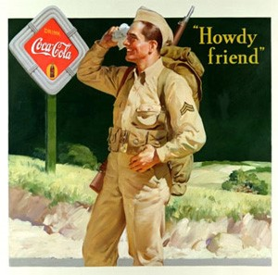  “The French communist party… asked “will we be coca-colonists?” … [French] Communists also charged that the Coca-Cola distribution system would double as an American espionage network. And the rumor spread that  A) Explain the connection between Coca-Cola and the American army during World War II discussed by Standage, and how that relationship is illustrated in the above image.  B) Using the above passage and your knowledge of the Standage book, explain why some people objected to the global spread of Coca-Cola.  C) Identify and explain another example (that is to say, not in France) of opposition to Coca-Cola. | Evaluate the degree to which World War II (1939-1945) represented a turning point in the economic influence of the United States abroad.  Thesis: World War II represented a turning point for America’s global economic influence because American support for allies during the war led to the diffusion of a wide variety of American products into foreign markets and established America as one of two global economic superpowers. However, it was not a turning point in the sense that America was already one of the world’s leading industrial and financial powers before the war. | Analyze the degree to which the development of cola drinks in the late 19th and early 20th century represented the changes brought about by the industrial revolution.

Examples

Framework: SAQ- Chapter Water
SAQs have three (3) parts to them. They are all written the same way. Use this example as a guide for all three aspects of an SAQ.
Q: Part A - Identify and explain one way in which the adoption of agriculture forced humans to change their behavior.

A: Part A - As a result of their adoption of agriculture, humans began to specialize in specific jobs rather than all working collectively to produce food. The growing of high calorie crops like wheat and rice on a large scale meant that only some people were required to produce food. This freed other individuals to function as specialized priests, warriors, and artisans who could rely on food produced by the farmers in their communities.

Framework: LEQ- Chapter Water
Q: Analyze factors responsible for the increasing importance of water in the 21st century as articulated by Standage

Thesis (provided): According to Standage, the growing significance of water in the 21st century is a product of new technology which made water safer to drink and more broadly available in the developed world as well as global population growth which places increasingly high demands on the essential but limited water supply

Evidence examples:
- Standage points out that in 2003 global bottled water sales topped 46 billion dollars (267).
- The author argued that 1.2 billion people worldwide do not have access to safe drinking water (269).

Framework: DBQ- Chapter Water

Q: Analyze factors responsible for the increasing importance of water in the 21st century as articulated by Standage

Thesis: According to Standage, the growing significance of water in the 21st century is partially a result of the increasing political importance attached to water supplies as well as the increasing scarcity of clean water due to population growth and pollution. Conversely, these difficulties have also made water an important tool in international cooperation as nations use water as a vehicle to promote peaceful coexistence.

Context: In the aftermath of imperialism and two World Wars, holding onto territory when challenged is increasingly seen as one of the prime tests of national sovereignty in the modern world. This is a fact of life for new states in former colonies in sub-Saharan Africa and Asia which became independent and struggled to make a place for themselves in the global community. Simultaneously, nations like Russia and China have used the acquisition of new territory in Ukraine and the South China Sea, respectively, as ways to demonstrate their strength and challenge their neighbors’ international credibility. Governments who give in to such aggressions are viewed as “weak” or “appeasers” which can create both domestic and foreign political problems. Given that the land so coveted by these states contains water which is in increasingly short supply as global population swells beyond seven billion, it is logical that control of water would become part of the increasingly complex political computations made by modern political states both to ensure domestic support and establish their reputation abroad.

